Testbed Deployment of K leader Election Protocol

A. Testbed Architecture
A simulation study has been reported above to assess the performance of our weight-based K leader election algorithm. To further demonstrate the feasibility of the algorithm in real applications, we implement it in a WSN testbed. The testbed, as shown in Figure XXXX contains 40 MicaZ [] nodes with a MIB600 gateway deployed in room QT 415 in the 4th floor of Mong Man Wai building.
In order to make our system more flexible, we implemented a three-layer-architecture. On the bottom, we have a topology layer which ensures end-to-end routing among network nodes. Above that layer we have neighbor layer which maintains the neighborhood of every node. The top layer is the application layer which implements the weight-based K-leader election protocol. We assign random numbers to different sensor nodes as weights. K is chosen as ⌈N/4⌉, where N is the total number of nodes in the network.

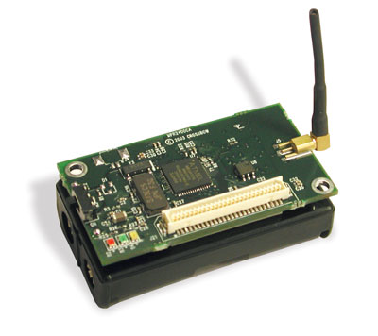 | 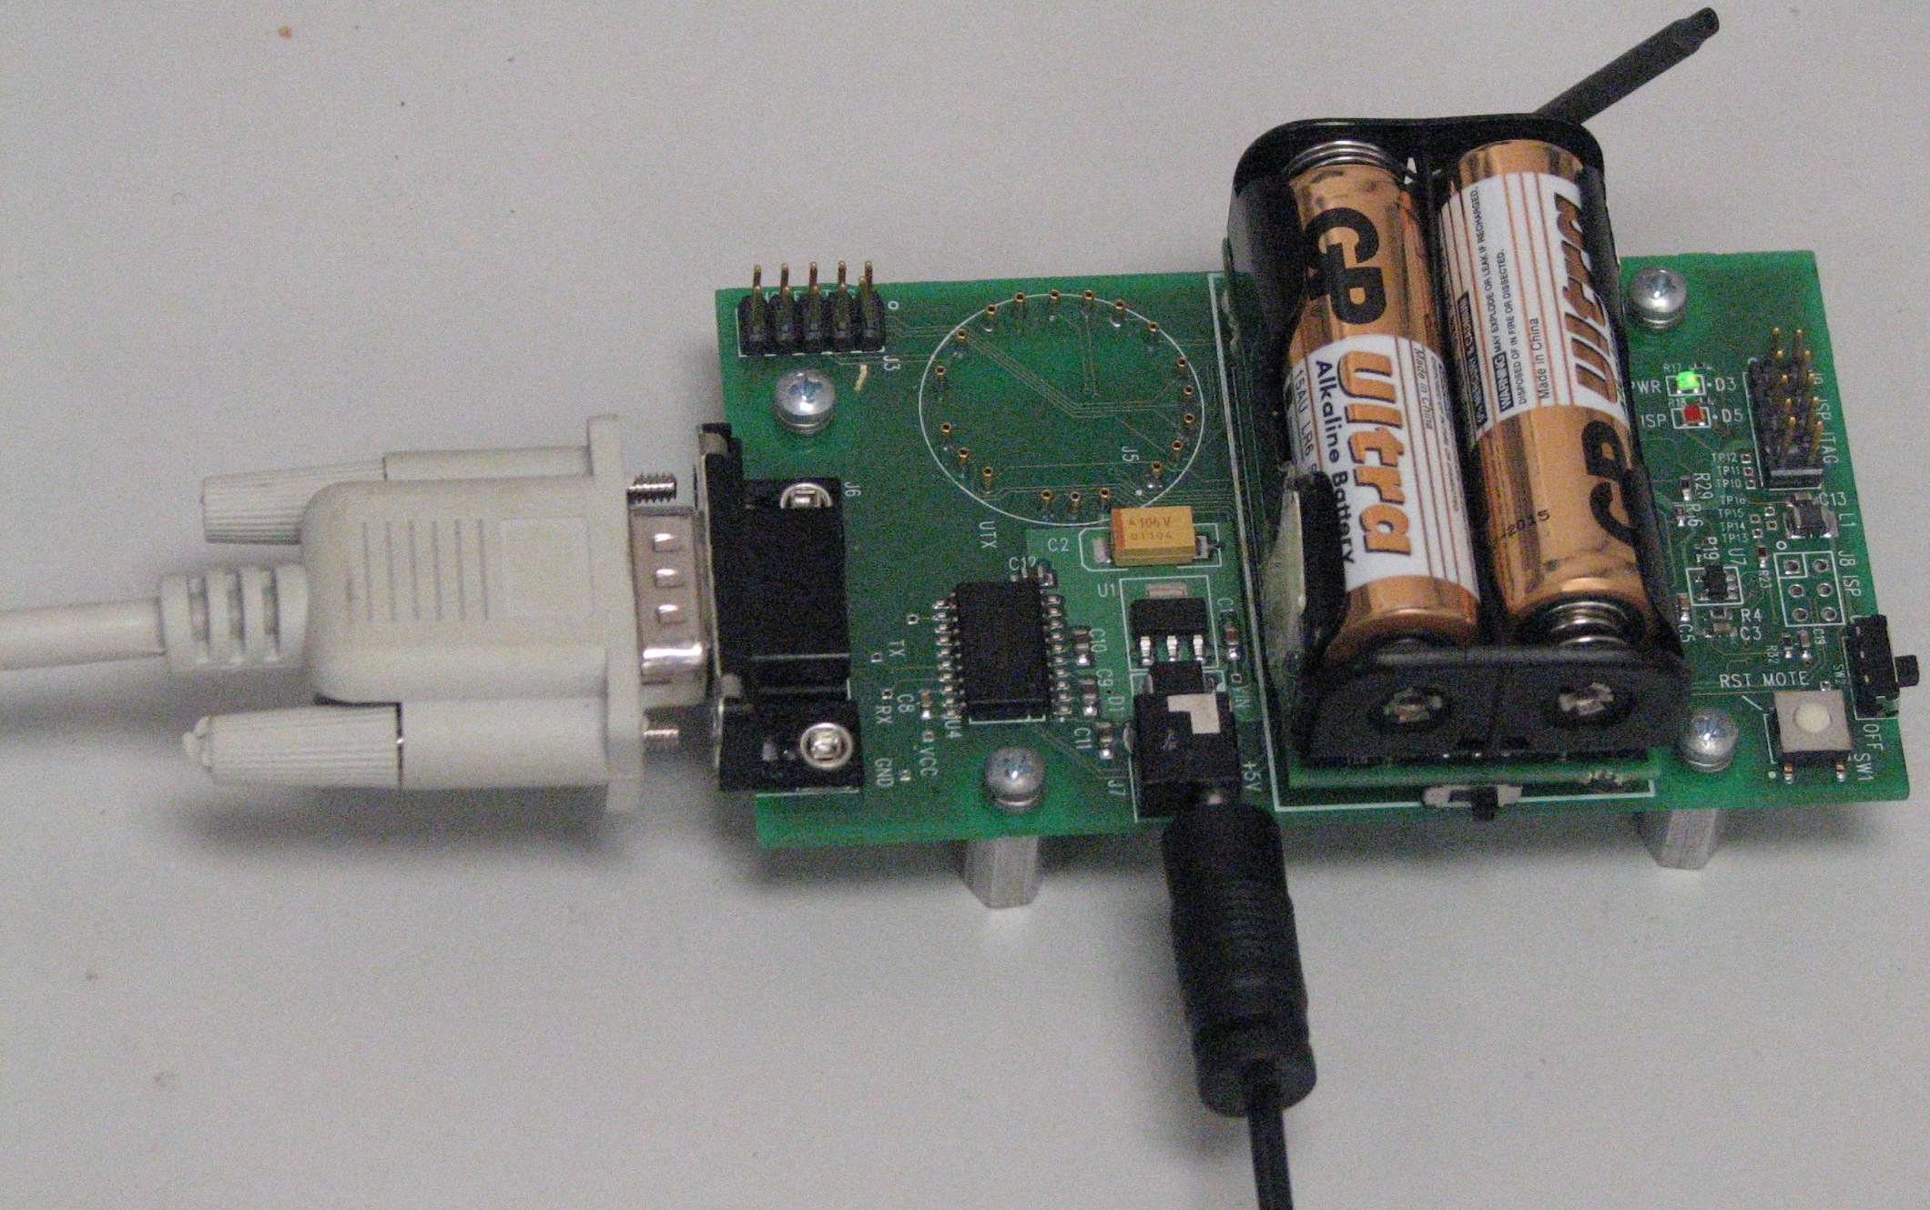 | 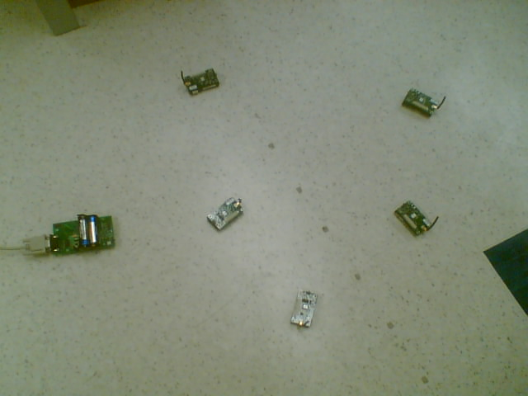
Fig. 1(a): MicaZ Node | Fig. 1(b): MIB600 Gateway | Fig. 1(c): Part of the Testbed

We have only implemented our basic K leader election algorithm without considering node mobility, node failure or network partitioning. We measured the number of messages and total time taken for a single election. We also implemented the “Vasu” protocol and compared our results with theirs.

B. Implementation
In order to implement our algorithm using TinyOS, we have adopted an event-driven model. We have a set of states and a set of events. Based on the events we divide the protocol into multiple states. Every node will be in a particular state at any instant during the execution of the algorithm. Node states are changed by triggering of an event. We have mainly three events – send message, receive message and timeout. Our node states are – init, wait-for-elect, receive-all-elect, send-vote, phase-two, receive-search, send-attach, forward-search, wait-for-signal, and phase-three. One critical challenge we faced during the implementation of our algorithm is due to absence of message ordering. Messages are delayed arbitrarily and they arrive at different times. So, we needed to handle all these cases carefully.
We measured the performance of our algorithm using two metrics – total number of messages exchanged for one election and total time for a single election. We tested the system with 10, 20, 30 and 40 nodes. We generated random topologies with different seeds each time, and use the topologies to carry out experiments. The experiment is run for 10 times each with different topologies for a fixed number of nodes. So, with 10 nodes the experiment runs for 10 times and with 20 nodes another 10 times, and so on, each with different topologies and the average values are reported.
In addition to the testbed system itself, we also have a special node (node 0) employed to monitor the system performance. Initially, when the execution starts, each node undergoes a bootstrapping phase to initialize the variables and chooses a random weight value. After that the node 0 broadcasts the topology information to all the nodes in the network. When a node receives the topology, it populates its neighbor list and starts the K leader election at randomly chosen time. When the execution finishes with K leaders elected, node 0 sends the performance results to the computer.

THE REMAINING PART IS NOT IS COMPLETE…………..

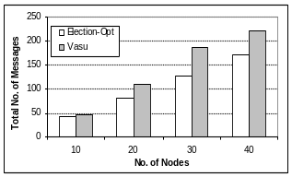 | 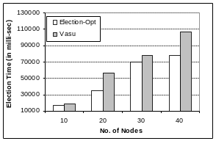 | 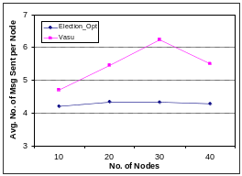

Result Analysis and Lessons Learned

We have done some experiments based on the whole system. The experiment results are shown in Table 2 and agree with our simulation.

